CURRICULUM VITAE
Basic Information:_________________________________________________________________________
Name: Aya Eid Mohamed Ali .
Address: Harbshant -beba –bani seuf.
Mobile: 01275667821.
Email: …ayaeid@lira.bsu.edu.eg. 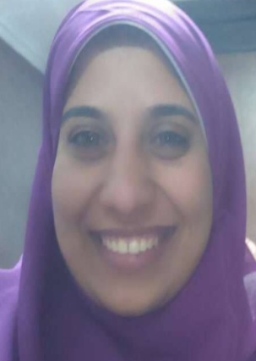
Profile: (maximum 5 lines)__________________________________________________________ ________
Marital status: Married
Gender: Female.
Date of birth: July 1 ,1993.

Education :_________________________________________________________________________________
- B.Sc. Of sciences Beni Sueif university, May,2016.
2) Prerequisite graduate courses towards the M.Sc., degree: (with general grade very good), Faculty of science, beni sueif University, Academic year 2017.
3) Diploma of biological laser applications, laser institute for research and applications (lira),beni sueif university.
Professional Experience: _______________________________________________________________________
1)Demonstrator of laser application in biology department ,laser institute for research and applications , Beni Sueif

